Project Design Phase
Solution Architecture

Date | 16/02/2026
Team ID | SWTID-2026-4180
Project Name | Contact Manager
Maximum Marks | 4 Marks

Solution Architecture:
The solution architecture for the Contact Manager application provides a scalable, efficient, and user-friendly platform for storing, updating, searching, and managing contact information. The system allows users to add new contacts, edit existing details, and quickly retrieve saved contacts whenever required.
The architecture follows a client-server model, where the user interacts with the application interface. The request is processed by the Node.js and Express backend server, which communicates with the MongoDB database to store and retrieve contact information.
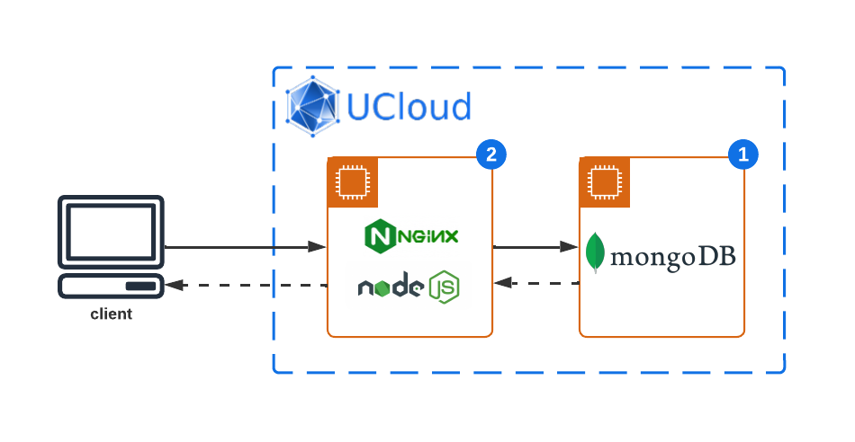

Goals of the Solution Architecture:

Identify the Best Tech Solution
• Utilize modern backend technologies such as Node.js and Express.js to build a fast and efficient application.
• Use MongoDB as the database to store contact information securely and efficiently.

Define Structure & Characteristics
• Ensure the system architecture is modular, scalable, and easy to maintain.
• Allow future improvements such as bulk addition, bulk deletion, and advanced search features.

Outline Features & Development Phases
• Clearly define the development stages including database schema creation, API development, and data management operations.
• Implement CRUD operations (Create, Read, Update, Delete) for contact management.

Establish Specifications for Development & Delivery
• Provide clear guidelines for API development, data flow, and system communication.
• Ensure the application handles data storage, retrieval, and updates efficiently.

